Midterm Mastery (Part II)

Step III: Crashing and recovering!

1. Latency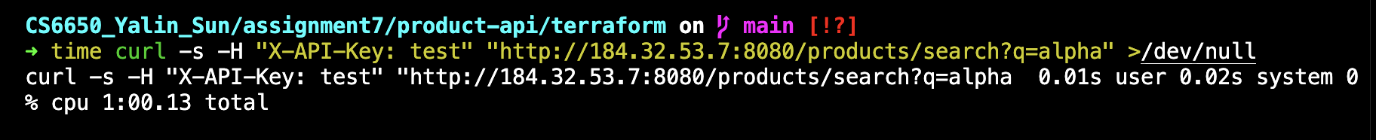

2. CPU utilization
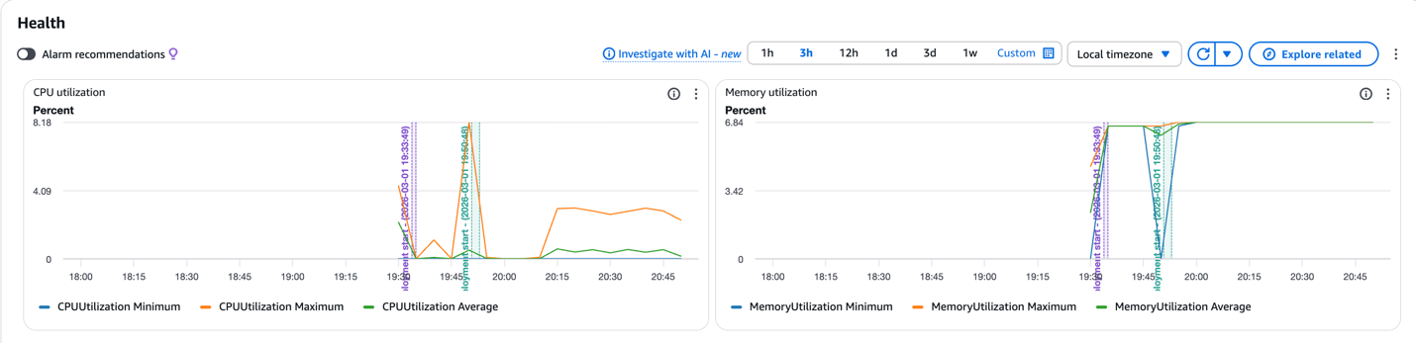

3. CloudWatch logs
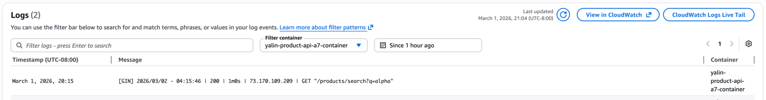

4. Problem + flaky

Test A: Baseline
User:5
Spawn rate: 5
Time: 2 mins

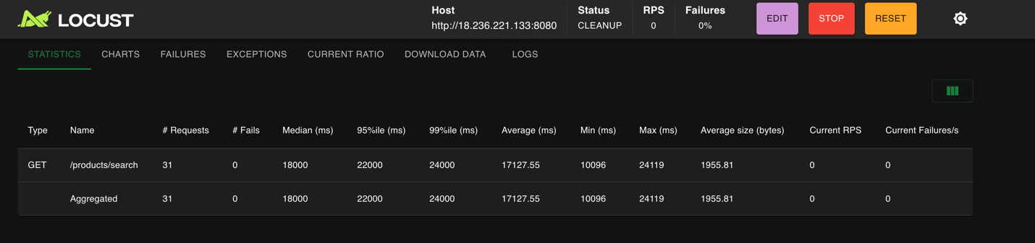
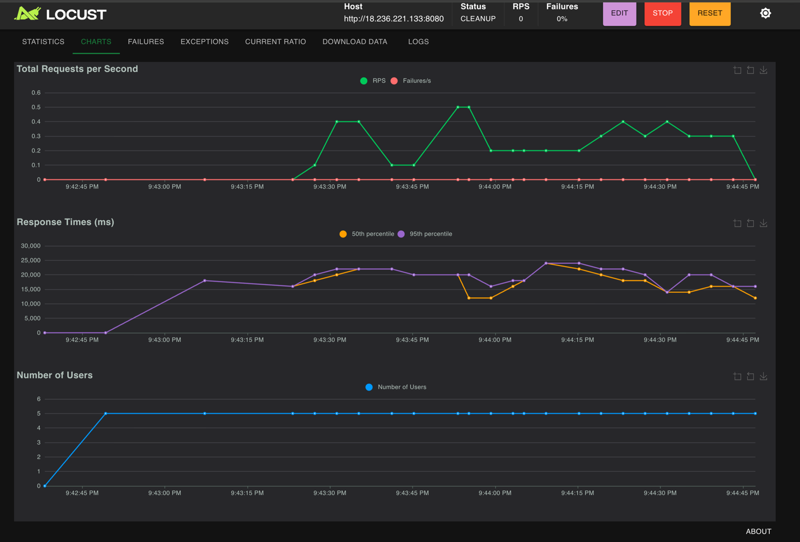

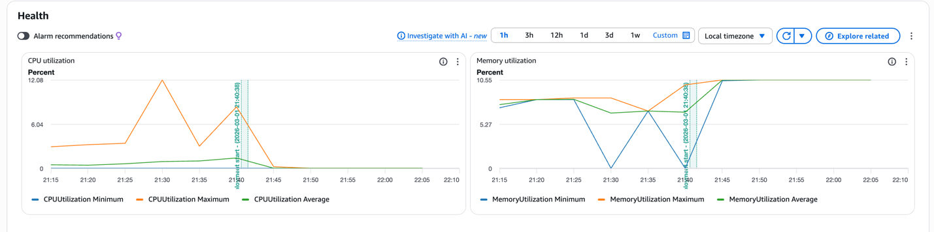

Test B
Users: 20
Spawn rate: 10
Duration: 3 mins

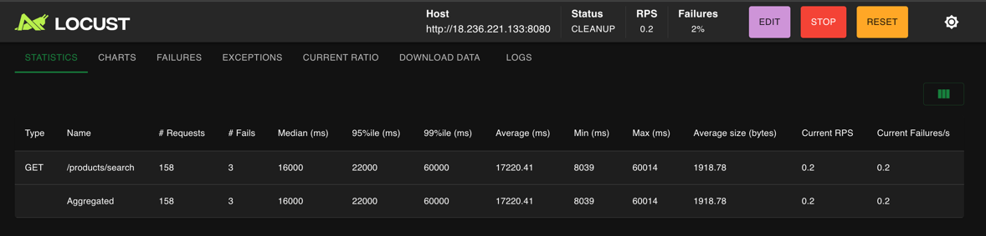

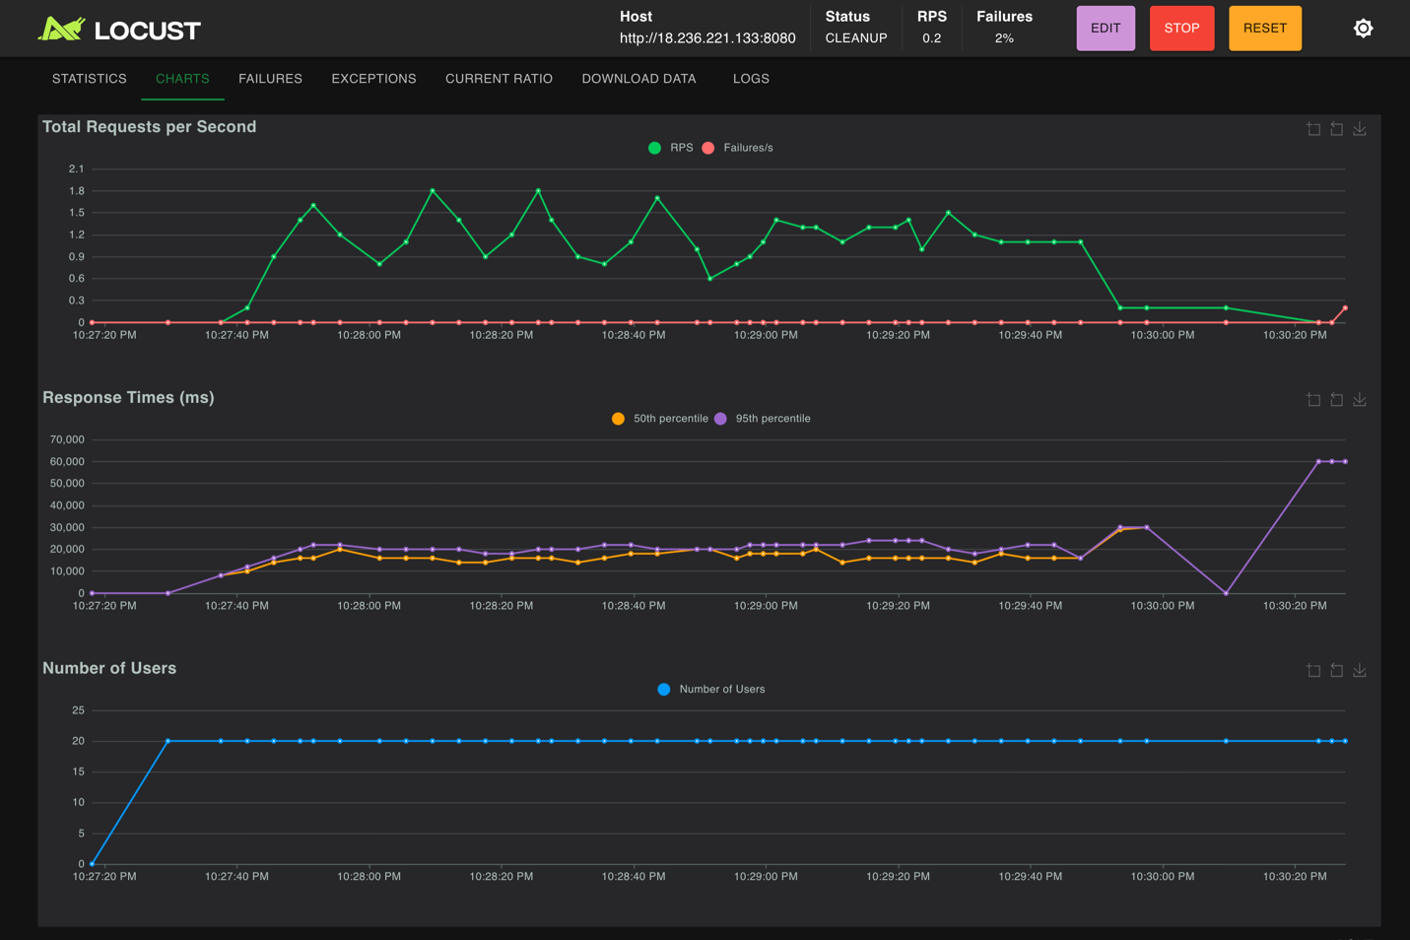

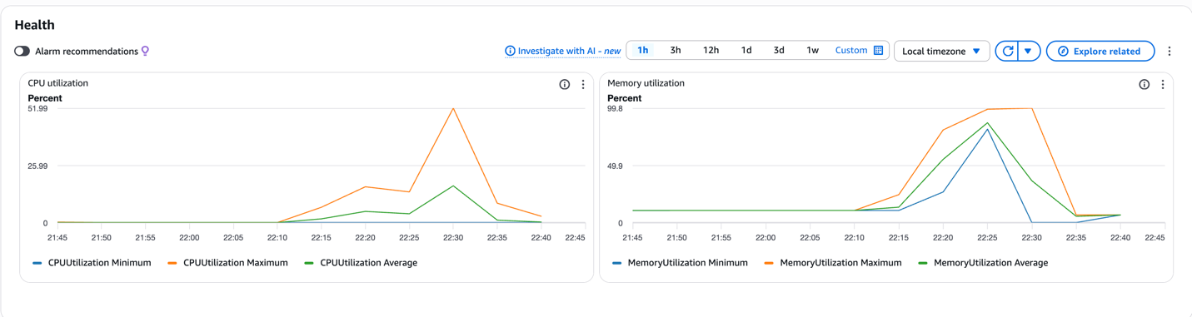

5. Fix + Flaky

Test A: Baseline
User:5
Spawn rate: 5
Time: 2 mins
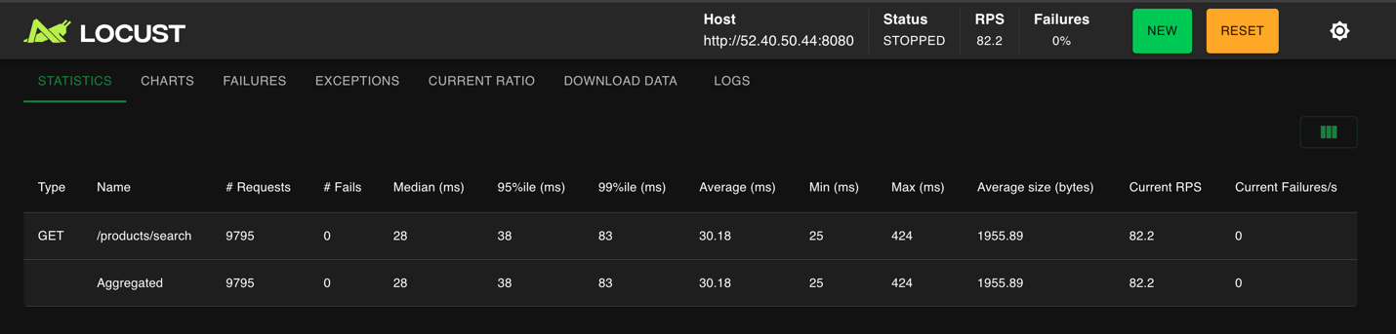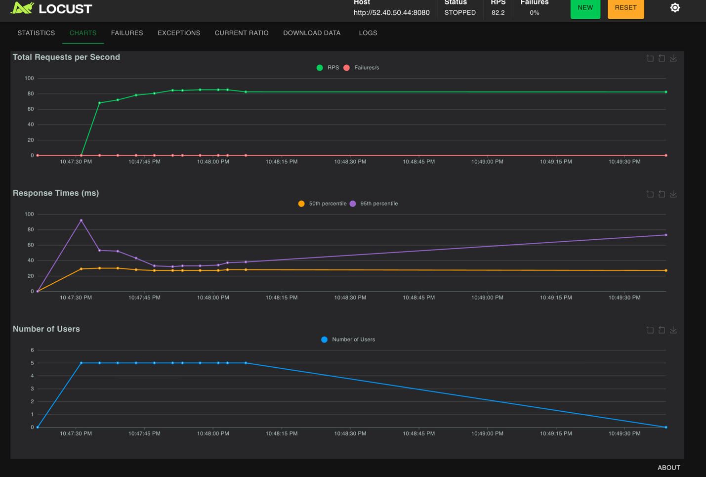

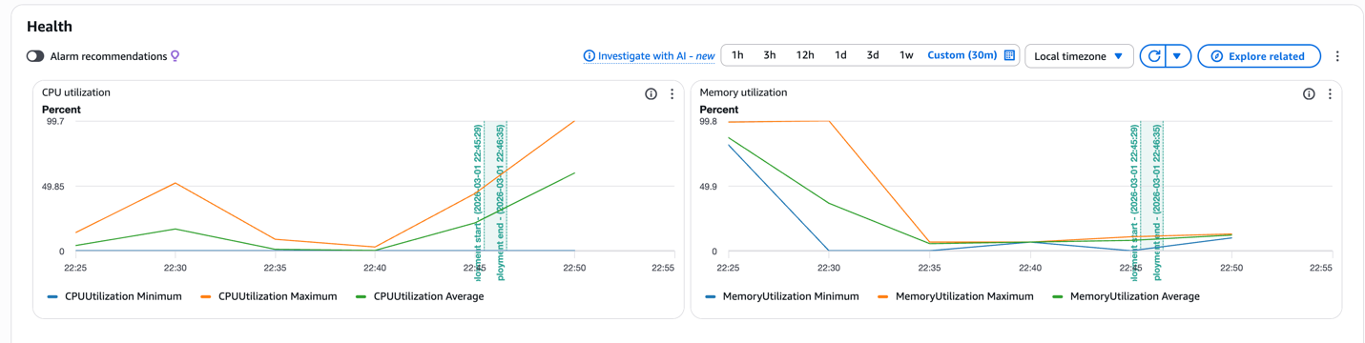

Test B:
Users: 20
Spawn rate: 10
Duration: 3 mins

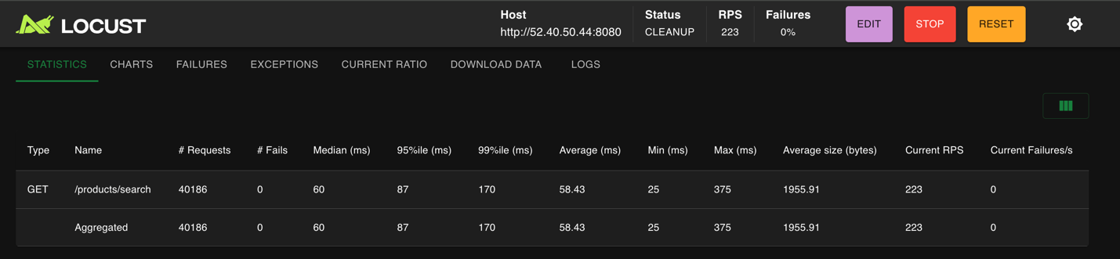
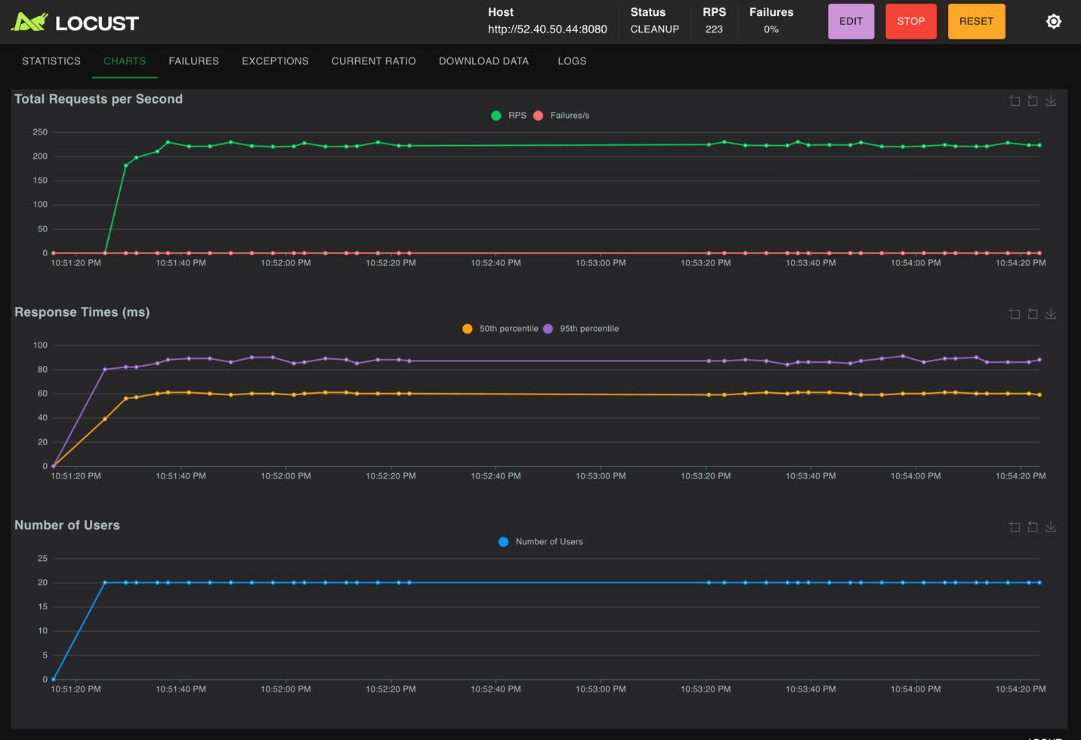

Introduction
In this part of the assignment, I designed a system that can fail on purpose, and then I fixed it.
The goal is to show:
- a bad system that crashes or behaves poorly
- how I fixed the problem
- how the system behaves better after the fix
The application is based on my previous assignment service.

1. Bad Version: How I Designed the Failure
What the Bad Version Is
In the bad version, I made the application flaky.
This means:
- some requests fail randomly
- some requests become very slow
This is similar to real systems where:
- a dependency is unstable
- or the service cannot handle load well
In this version, the system does not protect itself.
Requests keep coming in even when the system is already unstable.

How the System Failed
I used two load tests to show the problem.
Test A (small load)
- Users: 5
- Spawn rate: 5
- Time: 2 minutes
Even with small load:
- latency became unstable
- some requests failed
Test B (higher load)
- Users: 20
- Spawn rate: 10
- Time: 3 minutes
With higher load:
- latency spikes were very clear
- error rate increased
- CPU usage went up and down a lot
CloudWatch logs showed many errors.
This shows the system does not fail gracefully.

2. Fix: How I Improved the System
Idea of the Fix
To fix the problem, I changed the system to be more defensive.

Main ideas:
- fail fast: return error early instead of waiting too long
- limit damage: do not let bad behavior affect the whole system
The goal is:
- fewer retries
- faster recovery
- more stable behavior

What Changed (High Level)
After the fix:
- the system stops bad requests earlier
- CPU is not wasted on long failing requests
- the system can recover faster
Failures still happen, but they are controlled.

3. Good Version: Results After the Fix
I ran the same tests again after the fix.

What Improved
Latency
- latency is more stable
- fewer big spikes, especially in Test B
CPU Usage
- CPU usage is more stable
- fewer sudden jumps
CloudWatch Logs
- fewer error messages
- system behavior is more consistent
The system continues to serve requests instead of breaking down.

Conclusion
In this experiment, I first showed a system that fails under load.
Then I fixed it using simple resilience ideas.

After the fix:
- the system is more stable
- failures are easier to handle
- recovery is faster
This shows why it is important to design systems that can fail and recover, not only systems that work in perfect conditions.

